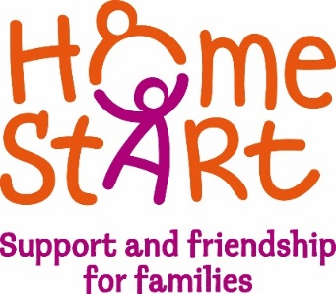
Home-Start South & West Devon
Volunteer Newsletter – November 2018
Join our Facebook Volunteer Only Forum. It is a place to chat to other volunteers and will include information on fund-raising and social activities. To join go to https://www.facebook.com/groups/360617027720363/
and click on join group on top left. It will ask you where you volunteer and then send a message to admin who will approve you.
Scheme Update
In addition to the lottery grant for our work in Torbay, we have now received a grant to continue our work across South Hams, West Devon and Plymouth. We still require some match funding over the next two years, but the service is secure for the next 2 years.

Volunteer numbers
We have just finished two Prep Courses, which takes the number of volunteers to 108. We are due to start two more courses at the end of January 2018, so if you know anyone who would make a good volunteer please encourage them to get in touch.

New staff
Our Torbay and South Hams Coordinator, Julie Hurrell, left us in September to start a new life in Spain. Following interviews, we have now appointed Halina Hart. She will be contacting South Hams and Torbay volunteers over the next few weeks.
In addition, we now have a Family Support Worker in Torbay. The role is designed to offer more intensive, short-term support to families with more complex needs. The role will be supported by volunteers who have undertaken additional training. Training courses have already been delivered and more will be offered in the New Year. Intensive support volunteers will visit a family for an hour, two or three times a week for 8 to 10 weeks. Support will be more targeted, for example, supporting a mum to implement routines, sort finances, manage behaviour.
We are also offering remote support to families. That is support by video, text or phone link. Again, initial training has taken place and will be offered again in the new year. Please contact the office or your Coordinator if you are interested.
These services will be offered in all areas, with a new family support worker role from March 2019.

Family Quotes

“It gave me confidence on a practical level. It was good to have someone to talk to who is objective”
“My volunteer visited every week. It has given me confidence by going out and doing things. It’s also, given me reassurance that I'm a good parent. We built friendship and trust to be honest. Just her presence helped me not to go into a panic attack!”
Thank you!

“It kept me sane. It gave me confidence, support and reassurance”

Diary Dates

Christmas Party!
We are holding a volunteer ‘bring a plate’ Christmas Party at The Rees Centre, Plympton on Friday 14th December. Everyone is welcome. There will be Christmas Fizz, a free raffle and secret santa. Please RSVP the office by the end of December. We look forward to seeing you all there.
Help needed
We are putting up a tree in Christmas Tree Festival in Kingsbridge this year. The tree is on show from Saturday December 1st until January. The Christmas Festival takes place in Kingsbridge with stalls etc in the high street on Saturday 1st December.

We would be very grateful if a volunteer or two could spare some time to decorate our tree and perhaps hand out flyers etc on Saturday December 1st.
2019 – What next?
In March/April we will be offering a Volunteer Conference, in partnership with other South West Schemes. We will send details and invites in the New Year.
We will be inviting families and volunteers to join our ‘Focus Groups’ to help guide the service.
We will complete our Strategic Plan, taking forward the work we did at our Vision Day.

